Background notes on

A Tour of Rural Data in Statistics Canada

Ray D. Bollman
DRAFT Feb 27, 2026
(Comments / questions are invited
so that I can improve this draft.
Thanks. Ray)

Background notes for a webinar presentation on
“A Tour of Rural Data in Statistics Canada”
organized by the Canadian Rural Revitalization Foundation (https://crrf.ca/)

March 24, 2026

Contents
1. Introduction 3
2. Where to start? 4
3. What is rural? 6
4. Geographic units that may be classified as “urban” or “rural” 7
a. Three key geographic units / building blocks 7
b. Classification based on DENSITY alone 10
c. Classifications based on DENSITY and DISTANCE-to-DENSITY 13
d. Classifications based on DISTANCE alone 22
e. Classifications: Other 23
f. Issue of nomenclature 25
g. Bottom line: There is no “correct” classification of rural. 25
5. Data sources 26
a. Start at the Statistics Canada DATA page 26
b. Census of Population 26
c. Annual Demographic Estimates 29
a. Labour Force Survey 31
d. Rural Canada Business Profiles 34
e. Canadian Survey of Business Conditions 35
f. Business openings and business closures 36
g. Canadian Social Survey 37
h. Employment Insurance Statistics - Monthly (EIS) 41
i. Building permits 41
j. Trade: Exports and Imports of Goods 41
k. Non-profit organizations 42
l. Health of Canadians 42
m. Canada Emergency Business Account (CEBA) 43
n. Canada Emergency Wage Subsidy Regional and Community-level Database 43
o. Selected population characteristics within ecozones, ecoprovinces and ecoregions 44
p. Gross Domestic Product for Non-metro (Non-CMA) areas 44
q. Other data sources 48
Appendix A: Selected notes regarding Statistics Canada 49
Appendix B: Quotation in the January, 2026 issue of “The Rural Roundup” 50

Figure 1. Six “Economy” Rural and Small Town Canada Interactive Dashboards 4
Figure 2. Four “Society” Rural and Small Town Canada Interactive Dashboards 5
Figure 3. The two dimensions of rurality: density and distance-to-density 6
Figure 4. Population in Population Centres and in (Census) Rural Areas, Canada, 1851 to 2016 11
Figure 5 . Ten-year Population Change, Canada, 1851 to 2011 12
Figure 6. Canada’s (census) rural population represented 19% of Canada’s total population in 2016 13
Figure 7. Population in Non-metro (Non-CMA) areas, Canada, 1986 to 2016 27
Figure 8. Five-year Change in Population in CMA, CA and Rural and Small Town areas, Canada, 1966 to 2016 28
Figure 9. Population in CMAs, CAs and Rural and Small Town Areas, Canada, 1966 to 2016 29
Figure 10. Employment in Manufacturing in Larger Urban Centres (CMAs and CAs) and in Rural and Small Town Areas, Ontario, 2014 to 2021 32
Figure 11. Number of Active Businesses, Ontario, 2017 to April, 2020 37
Figure 12. Size of Non-metro (non-CMA) Population and Size of Non-metro GDP, Canada, 2009 to 2020 46
Figure 13 Hierarchy of Standard Geographic Areas for Dissemination for 2021 Census of Population 51

Table 1. Geographic Units Associated with Each Dimension of Rurality 9
Table 2. Data Sources for Each Dimension of Rurality 9
Table 3. Population by Type of Labour Market and by Type of Settlement, Canada, 2006 15
Table 4. Average Family Income by Type of Settlement and by Type of Region (Type of Labour Market), Canada, 2006 16
Table 5. Percent Reporting High Life Satisfaction by Density (size of population centre) and by Distance-to-Density (type of commuting zone), Ontario, 2012 to 2024 21
Table 6. Gross Domestic Product, Employment and Population in Metro (CMA) Areas and in Non-metro (non-CMA) areas, Canada, 2009 to 2020 45
Table 7. Gross Domestic Product (GDP) and Population by a Density Dimension and a Distance-to-Density Dimension (calculated from a 1km by1km grid), Canada. 2019 47

Background notes on
A Tour of Rural Data in Statistics Canada

Introduction

The objective of this paper is to document the supply of rural data published by Statistics Canada.

Perhaps obviously, many other departments and agencies also publish rural data.

And, yes, after all of that, there are definitely data gaps.

As every analyst and decision-maker understands, the value of data / information may be measured by the increase in the value of a decision, relative to the value of the decision that would have been made without the data / information. Better data enables better decisions.

At the end of this paper, we note that the share of Canada’s population residing in rural areas and the share of Canada’s GDP produced in rural areas is essentially the same. From this point of view, ‘rural Canada is doing its part’.

In this paper, we will discuss:
- the various geographical units that may be classified as rural or urban; and then we will discuss
- the availability of rural data for each of these geographical units.

As you might appreciate, there is a lot of nitty-gritty behind of all of this. I will point out some important nitty-gritty considerations. However, for any line of attack, I suggest that you look at:
- the nitty-gritty regarding how the boundaries of each geographical unit are defined; and also look at
- the nitty-gritty on how each geographical unit is classified as rural or urban.

And also, apologies to colleagues who asked for suggested ways to use these data to measure the economic strength of a given community / region. I think such discussions warrant attention on another day.

Where to start?

For a menu of rural data at Statistics Canada, go to the Rural Statistics Data page at https://www.statcan.gc.ca/en/subjects-start/society_and_community/rural_canada.

This page will point you to various rural and small town interactive dashboards (Figure 1 and Figure 2). I shall be offering a review of each of these topics.

Figure 1. Six “Economy” Rural and Small Town Canada Interactive Dashboards

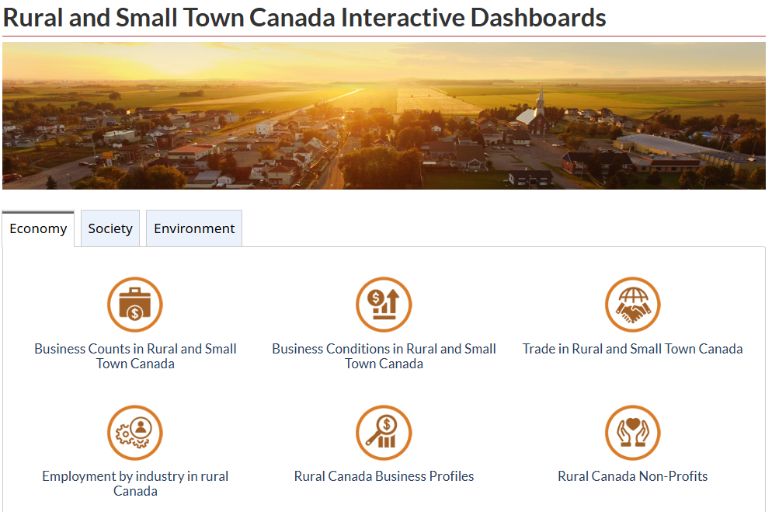

Figure 2. Four “Society” Rural and Small Town Canada Interactive Dashboards

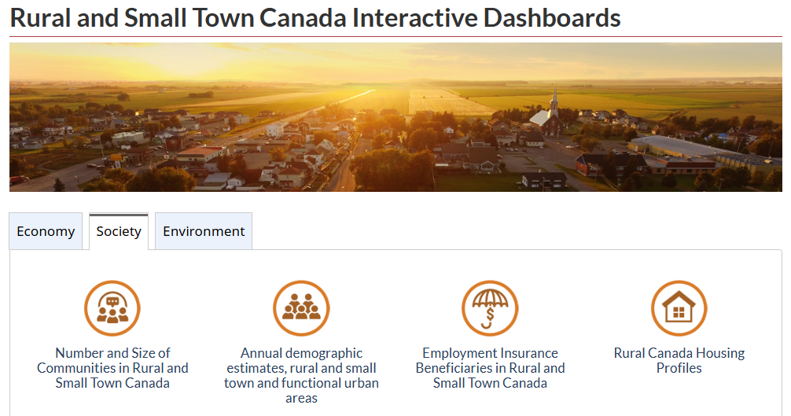

Also, you will see an option to get monthly updates and release notifications by clicking on “Subscribe to or mailing list for rural data” which will take you to: https://www.statcan.gc.ca/en/subjects-start/society_and_community/rural_canada/subscribe

If you have rural data questions, the email address for the “Rural Client Services” is: fe-ruralclientservic@statcan.gc.ca

The link to the Rural Data Lab video is: Video - Rural Data Lab: Understanding Rural and Small Town Canada Through Data.

To find all data available from Statistics Canada, go to the Statistics Canada DATA page at (https://www150.statcan.gc.ca/n1/en/type/data). There are filters for subject matter and for geographic location and for data frequency and for survey or statistical program. For example, at the top left, you see that there are 2,988 tables of Census data.

Suggestions:
- Whenever that you open a table at the Statistics Canada DATA page, I suggest clicking on “Add/Remove Data” in order to see all the available dimensions / categories in the table.
- Then, for formatting the table before downloading, I suggest that you click on “Customize Layout” to get the arrangement of columns and rows that you will want in your Excel table.
- For download options, I suggest choosing “CSV: Download as displayed (excluding accompanying symbols)”

One source that points to the various sources of rural data, that is certainly somewhat out-of-date, is:
Rural Ontario Institute. (2017) Small Area Data Guide (Guelph: Rural Ontario Institute).

What is rural?

My view is that there are two dimensions of rurality: “density” and “distance-to-density” (Figure 3).

Figure 3. The two dimensions of rurality: density and distance-to-density

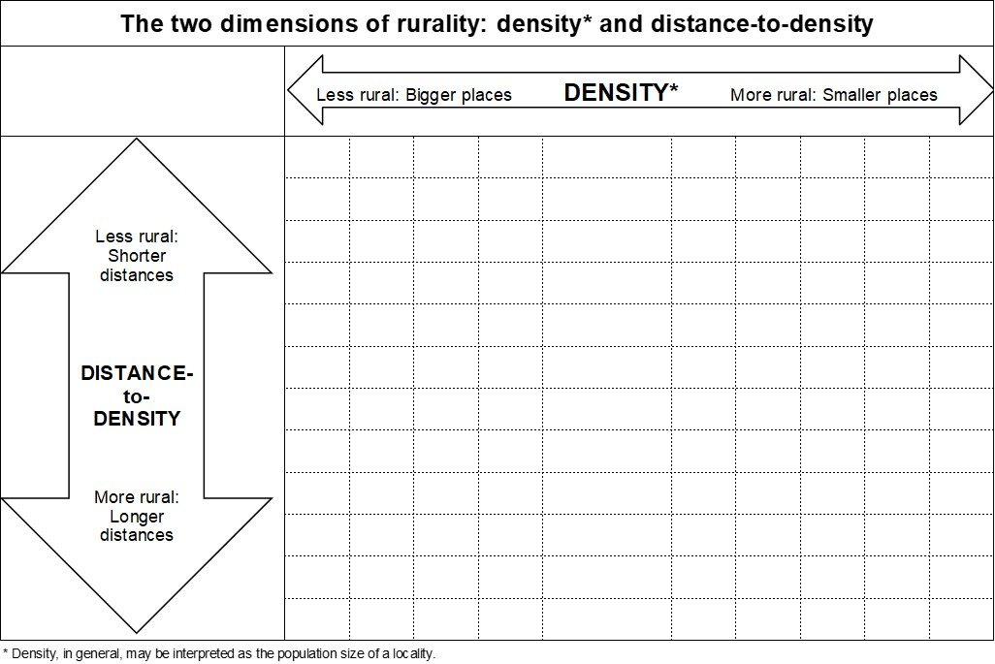

For discussion, see:

Bollman, Ray D. and Bill Reimer. (2018) The dimensions of rurality: Implications for classifying inhabitants as ‘rural’, implications for rural policy and implications for rural indicators. Paper presented to the 30th International Conference of Agricultural Economists, July 28 to August 2, Vancouver (https://ageconsearch.umn.edu/record/277251/files/1467.pdf).
[Summary of submitted paper “The dimensions of rurality: Implications for classifying inhabitants as ‘rural’, implications for rural policy and implications for rural indicators”]

Bollman, Ray D. and Bill Reimer (2019) “What is rural? What is rural policy? What is rural development policy? Chapter 1 in Vittuari, M., J. Devlin, M. Pagani and T.G. Johnson (ed.) The Routledge Handbook of Comparative Rural Policy (London: Routledge), pp. 6-26.

Bollman, Ray D. (2022). “Density Matters and Distance Matters: Canadian Public Policy from a Rural Perspective.” Chapter 13 in Karen R. Foster and Jennifer Jarman (ed.) The Right to be Rural (Edmonton: University of Alberta Press).

Hamond et al. (2026) propose categories of rural and urban in their grid of “density” and “distance-to-density”.

Hammond, Danika, Sarah-Patricia Breen and Ryan Gibson. (2026) “A rural matrix: A pragmatic alternative approach to defining rural for policy and practice.” Journal of Rural Studies, Volume 123, March 2026.

Geographic units that may be classified as “urban” or “rural”

Three key geographic units / building blocks

The three key geographic units that are used to classify “urban” and “rural” are
- Dissemination blocks (DB);
- Census subdivisions (CSD); and
- Census divisions (CD) (See the rows in Table 1).

Dissemination block (DB)

A dissemination block (DB) is an area bounded on all sides by roads and/or boundaries of Statistics Canada's standard geographic areas for dissemination. The dissemination block is the smallest geographic area for which population and dwelling counts are disseminated. Dissemination blocks cover all the territory of Canada.

Dissemination block boundaries were required to respect the following standard geographic areas: federal electoral districts (FEDs), census subdivisions (CSDs), census tracts (CTs), designated places (DPLs) and dissemination areas (DAs), health regions (HRs), local health integration networks (LHNs) and previous census population centres (POPCTRs).

(https://www12.statcan.gc.ca/census-recensement/2021/ref/dict/az/definition-eng.cfm?ID=geo014)

Dissemination blocks are small and each other geographic unit (almost) always is comprised of 2+ dissemination blocks.

- Census subdivision (CSD)

Census subdivisions (CSDs) are towns, municipalities or “equivalents” for statistical purposes.

Census subdivision (CSD) is the general term for municipalities (as determined by provincial/territorial legislation) or areas treated as municipal equivalents for statistical purposes (e.g., Indian reserves, Indian settlements and unorganized territories). Municipal status is defined by laws in effect in each province and territory in Canada.

A census subdivision is a grouping of dissemination blocks.

(https://www12.statcan.gc.ca/census-recensement/2021/ref/dict/az/definition-eng.cfm?ID=geo012)

- Census division (CD)

Census divisions are groupings of CSDs. They are counties or regional districts in some provinces and in other provinces, the groupings of CSDs was determined in consultation with provincial authorities.

Census division (CD) is the general term for provincially legislated areas (such as county, municipalité régionale de comté (MRC) and regional district) or their equivalents.

In other provinces and the territories where laws do not provide for such areas, Statistics Canada defines equivalent areas for statistical reporting purposes in cooperation with these provinces and territories.

Census divisions are a grouping of census subdivisions

(https://www12.statcan.gc.ca/census-recensement/2021/ref/dict/az/definition-eng.cfm?ID=geo008)

The 2021 list of census divisions is at https://www12.statcan.gc.ca/census-recensement/2021/ref/dict/tab/index-eng.cfm?ID=t1_4 and a map of 2021 census divisions is at https://www12.statcan.gc.ca/census-recensement/2021/geo/maps-cartes/referencemaps-cartesdereference/sgc-cgt/index2021-eng.cfm?year=21.

Table 1. Geographic Units Associated with Each Dimension of Rurality

Table 2. Data Sources for Each Dimension of Rurality

Classification based on DENSITY alone

- Population centres and (census) rural areas

Population centres and (census) rural areas are delineated as groupings of dissemination blocks. There is no consideration of their proximity / distance to another geographic unit

A population centre (POPCTR) has a population of at least 1,000 and a population density of 400 persons or more per square kilometre, based on population counts from the current Census of Population. All areas outside population centres are classified as rural areas.
Taken together, population centres and rural areas cover all of Canada.
Population centres are classified into three groups, depending on the size of their population:
- small population centres, with a population between 1,000 and 29,999
- medium population centres, with a population between 30,000 and 99,999
- large urban population centres, with a population of 100,000 or more.
The nitty-gritty is at (https://www12.statcan.gc.ca/census-recensement/2021/ref/dict/az/definition-eng.cfm?ID=geo049a)

Bottom line: (Census) “Rural” refers to the population outside centres of 1,000 or more. This has been the long-standing definition of rural within Statistics Canada.

The long-standing trend is a steady increase in the number of residents in population centres and a miniscule growth (but not a decline) in the residents in (census) rural areas (Figure 4).

Since 1851, there were two ten-year periods where the (census) rural actually declined: 1961 to 1971 and 1991 to 2001 (Figure 5). Interestingly, there was one ten-year period (1971 to 1981) when the number of (census) rural residents grew faster than the growth in the number of residents in population centres.
Figure 4. Population in Population Centres and in (Census) Rural Areas, Canada, 1851 to 2016

Figure 5 . Ten-year Population Change, Canada, 1851 to 2011

The share of Canada’s population residing in (census) rural areas has declined very slightly since 1981(Figure 6).

Figure 6. Canada’s (census) rural population represented 19% of Canada’s total population in 2016

Classifications based on DENSITY and DISTANCE-to-DENSITY

- Census subdivisions (CSDs) are often used for classifying geographic space as “rural” or “urban”.

Census subdivisions (CSDs) are used to delineate:
Census Metropolitan Areas (CMAs) (population of 100,000 or more)
Census Agglomerations (CAs) (population of 10,000 to 99,999)
Non-CMA/CA areas – often labelled as “rural and small town areas”

The density cut-offs are 100,000 and over for a CMA and 10,000 to 99,999 for a CA. In addition, the rurality dimension of “distance-to-density” appears because if a CSD has 50+% of employed individuals commuting to the CMA or CA, then that CSD is delineated as part of the CMA or CA. The details can be seen at https://www12.statcan.gc.ca/census-recensement/2021/ref/dict/az/definition-eng.cfm?ID=geo009. Some “details” are that there needs to be 50K in the central core (and 100+K overall) to qualify to be a CMA and there needs to be 10K in the central core to qualify to be a CA. Also, a CSD needs at least 100 commuters before it is attached to a CMA or CA.

Now . . . let the confusion begin
- As a town or city grows, the boundary of the population centre may cross over the boundary of the incorporated place (i.e., cross over the boundary of a census subdivision). Thus, there is a difference in the size of population of the “population centre” with a given name and the size of the incorporated place with the same given name.
- As a consequence, within any CSD, you may find residents of a population centre and you may find residents of a (census) rural area who live in the countryside outside a population centre.
- The trick is to recall that CMAs and CAs are constructed using CSDs as building blocks – but – population centres and rural areas are constructed with smaller units (dissemination blocks). This generates the result that within any CSD, there may be individuals residing in a population centre and there may be individuals residing in a (census) rural area.

Understanding this confusion is important. The census classification of residents of population centres (with a population of 1,000 or more) and residents of rural areas provides different results than the classification of CMA/CA residents and non-CMA/CA (i.e., rural and small town) residents. Only 2/3 of (census) rural residents live in a rural and small town area and only 2/3 of rural and small town residents live a (census) rural area (Table 2).

Table 3. Population by Type of Labour Market and by Type of Settlement, Canada, 2006

Time for a statistical quiz:

Q: Do rural residents have higher or lower incomes than urban residents?

A: The data (below) show
- Within CMA/CA areas, (census) rural residents have higher incomes.
- Within non-CMA/CA areas, (census) rural residents have lower incomes.

Table 4. Average Family Income by Type of Settlement and by Type of Region (Type of Labour Market), Canada, 2006

Recall the statistical quiz: Do rural residents have higher or lower incomes than urban residents?

The clear answer to our statistical quiz is definitely “yes”.

Bottom line:
- CSDs are towns, municipalities or “equivalents” for statistical purposes.
- Note that some dissemination blocks within a CSD might be part of a population centre and some dissemination blocks within a CSD may be a (census) rural area. Thus, any CSD may have residents of both a population center and a (census) rural area.
- CSDs are the building blocks for Census Metropolitan Areas (CMAs), Censu8s Agglomerations (CAs) and non-CMA/CA areas (often labelled as “rural and small town” (RST) areas.)
- From #2 above, RST areas may have residents in “population centres” and CMA/CA areas may have residents in (census) rural areas.

- Metropolitan Influences Zones

Census subdivisions within “rural and small town areas” (i.e., non-CMA/CA areas) have been delineated into Metropolitan Influenced Zones (MIZ). The delineation is based on the degree of commuting to a CMA/CA area. The specific categories:
Strong MIZ (30% to 49% commuting;
Moderate MIZ (5% to 29% commuting);
Weak MIZ (1% to 4% commuting); and
No MIZ (no commuting).

An overall explanation of Metropolitan Influenced Zones is at https://www150.statcan.gc.ca/n1/pub/92-195-x/2021001/other-autre/miz-zim/miz-zim-eng.htm.

For background information, see

McNiven, Chuck, Henry Puderer and Darryl Janes. (2000) Census Metropolitan Area and Census Agglomeration Influenced Zones (MIZ): A Description of the Methodology (Ottawa: Statistics Canada, Geography Working Paper Series No. 2000-2, Catalogue no. 92F0138MIE) (www.statcan.gc.ca/cgi-bin/downpub/listpub.cgi?catno=92F0138MIE).

Rambeau, Sheila and Kathleen Todd. (2000) Census Metropolitan Area and Census Agglomeration Influenced Zones (MIZ) with census data (Ottawa: Statistics Canada, Geography Working Paper Series No. 2000-1, Catalogue no. 92F0138MIE) (www.statcan.gc.ca/cgi-bin/downpub/listpub.cgi?catno=92F0138MIE)

The list of CSDs assigned to each Statistical Area Classification (SAC) group (i.e., each MIZ category) is shown in the GeoSuite database for each census year. See https://www150.statcan.gc.ca/n1/en/catalogue/92-150-X

A list of census subdivisions in each Metropolitan Influenced Zone and a map of Metropolitan Influenced Zones (2021 census geography) are at https://www12.statcan.gc.ca/census-recensement/2021/geo/maps-cartes/referencemaps-cartesdereference/sgc-cgt/map-eng.cfm?SGC=01_C.

A list of census subdivisions in each Metropolitan Influenced Zone and a map of Metropolitan Influenced Zones (2016 census geography) are at
https://www12.statcan.gc.ca/census-recensement/2016/geo/map-carte/ref/sgc-cgt/alternative-eng.cfm?file=2016-12572-01-C.pdf.

A map of Metropolitan Influenced Zones (2011 census geography) is at
https://www12.statcan.gc.ca/census-recensement/2011/geo/map-carte/pdf/2011-12572-01-C.pdf.

A map of Metropolitan Influenced Zones (2006 census geography) is at https://www150.statcan.gc.ca/n1/pub/21-006-x/2008003/c-g/maps-cartes001-eng.htm.
With any dataset with CSD data, analysts may group the CSD data into the MIZ categories.

Published data for the MIZ classification can be found by going to the Statistics Canada Data page and scrolling down to select “Census Metropolitan Influenced Zone” which then points to 8 tables with data by MIZ categories. Six tables show Employment Insurance Beneficiaries, one table shows infant and perinatal mortality by sex and one table shows birth-related indicators (low and high birth weight, small and large for gestational age, pre-term births) by sex.

- Census divisions (CDs)

Census divisions are groupings of CSDs. They are counties or regional districts in some provinces and in other provinces, the groupings of CSDs was determined in consultation with provincial authorities. (https://www12.statcan.gc.ca/census-recensement/2021/ref/dict/az/definition-eng.cfm?ID=geo008)

The 2021 list of census divisions is at https://www12.statcan.gc.ca/census-recensement/2021/ref/dict/tab/index-eng.cfm?ID=t1_4 and a map or 2021 census divisions is at https://www12.statcan.gc.ca/census-recensement/2021/geo/maps-cartes/referencemaps-cartesdereference/sgc-cgt/index2021-eng.cfm?year=21.

Various researchers have offered a classification of rural census divisions.

An early typology of census divisions (and still instructive IMHO – and ripe for updating by an enterprising researcher) was generated by Liz Hawkins:

Hawkins, Liz. (1995) Mapping the Diversity of Rural Economies: A Preliminary Typology of Rural Canada (Ottawa: Statistics Canada, Agriculture and Rural Working Paper No. 29, Catalogue no. 21-601MPE95029). (https://publications.gc.ca/collections/collection_2017/statcan/21-601/CS21-601-29-eng.pdf)

The map is clearer and in colour at p. 80 in

Hawkins, Liz and Ray D. Bollman (1994), "Revisiting Rural Canada -- It's Not All the Same," Canadian Agriculture at a Glance (Ottawa: Statistics Canada, Cat. No. 96-301)), pp. 78-80. (https://publications.gc.ca/collections/collection_2012/statcan/rh-hc/CS96-301-1994.pdf)

See also

Bollman, Ray D. (1994), "A Preliminary Typology of Rural Canada," in John M. Bryden (ed.), Towards Sustainable Rural Communities: The Guelph Seminar Series (Guelph: University School of Rural Planning and Development), pp. 141-145.

An early classification of OECD “predominantly rural regions” (census divisions in the case of Canada) is available at
https://www.oecd.org/content/dam/oecd/en/publications/reports/2011/08/oecd-extended-regional-typology_g17a1ff6/5kg6z83tw7f4-en.pdf#:~:text=The%20resulting%20classification%20consists%20of%20four%20types,city%20(PRC)%20and%20Predominantly%20Rural%20Remote%20(PRR).

The groupings of census divisions are:
Predominantly urban census divisions;
Intermediate census divisions;
Predominantly rural census divisions.

The “distance-to-density” criteria appears in the classification of intermediate census divisions which are adjacent to the predominantly urban census divisions.

Examples of OECD analyses of “predominantly rural regions” are:

Brezzi, Monica, Lewis Dijkstra and Vincente Ruiz. (2011) Extended Regional Typology: The economic performance of remote rural regions. (Paris: OECD, OECD Regional Development Paper 2011/06) (http://www.oecd.org/gov/regional-policy/48670214.pdf).

Garcilazo, Enrique. (2013) Growth Trends and Characteristics of OECD Rural Regions. (Paris: OECD Regional Development Working Papers, 2013/10) (https://www.oecd.org/en/publications/growth-trends-and-characteristics-of-oecd-rural-regions_5k4522x3qk9q-en.html)

Examples of Canadian publications showing data for predominantly rural regions includes:

Rupnik, Carlo, Juno Tremblay and Ray D. Bollman. (2001) “Housing Conditions in Predominantly Rural Regions.” Rural and Small Town Canada Analysis Bulletin Vol. 2, No. 4 (Ottawa: Statistics Canada, Catalogue no. 21-006-XIE) (https://www150.statcan.gc.ca/n1/en/catalogue/21-006-X).

Beshiri, Roland and Ray D. Bollman. (2001) “Population Structure and Change in Predominantly Rural Regions.” Rural and Small Town Canada Analysis Bulletin Vol. 2, No. 2 (Ottawa: Statistics Canada, Cat. No. 21-006-XIE). (https://www150.statcan.gc.ca/n1/pub/21-006-x/21-006-x2000002-eng.pdf)

Beshiri, Roland and Emily Alfred. (2002) “Immigrants in Rural Canada.” Rural and Small Town Canada Analysis Bulletin Vol. 4, No. 2 (Ottawa: Statistics Canada, Catalogue no. 21-006-XIE) (http://www.statcan.gc.ca/bsolc/olc-cel/olc-cel?catno=21-006-X&CHROPG=1&lang=eng).

Beshiri, Roland. (2004) “Immigrants in Rural Canada: 2001 Update.” Rural and Small Town Canada Analysis Bulletin Vol. 5, No. 4 (Ottawa: Statistics Canada, Catalogue no. 21-006-XIE) (http://www.statcan.gc.ca/bsolc/olc-cel/olc-cel?catno=21-006-X&CHROPG=1&lang=eng).

Beshiri, Roland and Ray D. Bollman. (2005) Immigrants in Rural Canada. Presentation to the 2005 Canadian Rural Revitalization Foundation – Rural Development Institute National Rural Think Tank (https://www.brandonu.ca/rdi/wp-content/blogs.dir/116/files/2015/09/Immigrants_in_Rural_Canada.pdf).

Bollman, Ray D., Roland Beshiri and Heather Clemenson. (2007) “Immigrants in Rural Canada.” In Bill Reimer (ed.) Our Diverse Cities No. 3 (Summer), pp. 9 – 15 (https://publications.gc.ca/collections/collection_2008/cic/Ci2-1-3-2007E.pdf).

More recent OECD methodologies to classify rural regions are presented in:

Dijkstra, L., H. Poelman and P. Veneri. (2019) The EU-OECD definition of a functional urban area, (Paris: OECD, OECD Regional Development Working Papers, Vol. 2019/11) https://doi.org/10.1787/d58cb34d-en.

EC et al. (2020) A recommendation on the method to delineate cities, urban and rural areas (Brussels: European Commission, Background document) https://unstats.un.org/unsd/statcom/51st-session/documents/BG-Item3j-Recommendation-E.pdf.

Fadic, Milenko, José Enrique Garcilazo, Ana Moreno Monroy and Paolo Veneri (2019), Classifying small (TL3) regions based on metropolitan population, low density and remoteness. (Paris: OECD, OECD Regional Development Working Papers, No. 2019/06). (https://doi.org/10.1787/b902cc00-en).

OECD. (2023) OECD Territorial Correspondance Table (Paris: OECD) https://stats.oecd.org/wbos/fileview2.aspx?IDFile=db68c5c3-5fd5-465cb25b-b50aa14c2da1.

For the application of these geographical structures, the OECD has a regular publication called OECD Regions at a Glance. The 2024 edition is available at https://www.oecd.org/content/dam/oecd/en/publications/reports/2024/12/oecd-regions-and-cities-at-a-glance-2024_134d05a6/f42db3bf-en.pdf.

- Classification of Thomson et al.

Thomson et al. (2025) propose a (somewhat) different approach to classifying the DENSITY and DISTANCE-to-DENSITY dimensions of rurality:

Thomson, Myfanwy, Maire Sinha, Simen Hemm and Lauren Pinault. (2025) Beyond urban and rural: Rethinking the social geography of Canada (Ottawa: Statistics Canada, Insights on Canadian Society, Catalogue number 75-006) (https://www150.statcan.gc.ca/n1/pub/75-006-x/2025002/article/00003-eng.htm).

Specifically, they look at the density dimension (i.e. size of population centres and (census) rural areas), and then, for each size class of population centres, the distance-to-density dimension is proxied by the size of the commuting zone in terms of whether one resides within a CMA or within a CA or within one of each of the MIZ CSDs. As an example, Table 5 shows the pattern of high life satisfaction in Ontario using their classification of rurality.

Table 5. Percent Reporting High Life Satisfaction by Density (size of population centre) and by Distance-to-Density (type of commuting zone), Ontario, 2012 to 2024

A simpler version of this classification was used in a paper looking at Canadians living beside a city:

Bollman, Ray D. (2010) “Canadians Living Beside a City: A Profile.” Chapter 3 in Beesley, Kenneth B. (ed.) The Rural-Urban Fringe in Canada: Conflict and Controversy (Brandon: Brandon University, Rural Development Institute), pp. 23-54.

Classifications based on DISTANCE alone

- Remoteness Index

For one measure of the “distance-to-density” for each CSD in Canada, see the “Index of Remoteness” at https://www150.statcan.gc.ca/n1/en/catalogue/17260001. The methodology is documented by

Alasia, Alessandro, Frédéric Bédard and Julie Bélanger. (2013) “Methodological issues in the development of accessibility measures to services: challenges and possible solutions in the Canadian context.” Presentation to the OECD Working Party on Territorial Indicators, Paris, June 18 (http://www.oecd.org/cfe/regional-policy/PPT-Alasia.pdf).

Alasia, Alessandro Frédéric Bédard, Julie Bélanger, Eric Guimond and Christopher Penney. (2017) Measuring remoteness and accessibility - A set of indices for Canadian communities (Ottawa: Statistics Canada, Catalogue no. 18-001) (https://www150.statcan.gc.ca/n1/en/catalogue/18-001-X).

The remoteness index has been updated:

Statistics Canada. (2023) Index of Remoteness 2021: Update with 2021 census geographies and populations (Ottawa: Statistics Canada, Catalogue no. 17-26-0001) (https://www150.statcan.gc.ca/n1/pub/17-26-0001/2020001/meta-doc-eng.htm)

The 2021 Index of Remoteness for each CSD can be downloaded at https://www150.statcan.gc.ca/n1/pub/17-26-0001/172600012020001-eng.htm.

- Proximity Index

Another measure of “distance-to-density” is available in the “Proximity Measures Database” which shows, at the level of the dissemination block, the degree of proximity to facilities such as a grocery store, pharmacy, and public transit stop within 1 km walking; a childcare facility, primary school, and library within 1.5 km walking; a health facility within 3 km driving; and employment within 10 km driving. Given these specifications, residents in the countryside are not assigned a proximity index. See https://www150.statcan.gc.ca/n1/en/catalogue/17260002. The methodology is documented by

Alasia, Alessandro, Nick Newstead, Joseph Kuchar and Marian Radulescu. (2021) Measuring proximity to services and amenities: An experimental set of indicators for neighbourhoods and localities (Ottawa: Statistics Canada, Reports on Special Business Projects, Cat. No. 18-001) (https://www150.statcan.gc.ca/n1/pub/18-001-x/18-001-x2020001-eng.htm).

Classifications: Other

- Self-contained Labour Areas (SLAs)

Self-contained labour areas are also delineated as groupings of CSDs.

An early delineation of SLAs was presented in:

Munro, Anne, Alessandro Alasia and Ray D. Bollman. (2011) “Self-contained labour areas: A proposed delineation and classification by degree of rurality.” Rural and Small Town Canada Analysis Bulletin Vol. 8, No. 8 (Ottawa: Statistics Canada, Catalogue no. 21-006-XIE) (www.statcan.gc.ca/bsolc/olc-cel/olc-cel?catno=21-006-X&CHROPG=1&lang=eng).

Munro et al. used reciprocal commuting flows to delineate the SLAs. The policy idea is that an SLA identifies a functional economic area in the sense that a job created in this area will be filled by a resident of the area – thus, there was little leakage to another area for a job created in a given area in terms of workers commuting into the given area from a neighouring area. This delineation of SLAs included most Strong MIZ CSDs as part of the ”functional area of a CMA or CA”.

This was a helpful delineation for users who wanted to know the extent of the ‘reach’ of each CMA and each CA and thus included a wider set of CSDs within the reach of a CMA or CA.

However, now users could see two versions of CMAs and CAs:
- There is the long-standing definition for CMAs and CAs which included CSDs where 50+% of the resident workforce in the CSD commuted to a CMA or CA. (Well, the nitty-gritty is not quite that simple. See https://www12.statcan.gc.ca/census-recensement/2021/ref/dict/az/definition-eng.cfm?ID=geo009.); and
- There is the idea of an SLA based on reciprocal commuting flows.

An excellent review of these issues in presented in

OECD (2020) Delineating Functional Areas in All Territories (Paris: OECD Territorial Reviews). (https://www.oecd.org/content/dam/oecd/en/publications/reports/2020/02/delineating-functional-areas-in-all-territories_1d8738a0/07970966-en.pdf)

For Canada, see pp. 55-56 for a discussion of the issues in Canada and see p. 79 for a sensitivity analysis concerning whether or not CSDs in CMA/CA areas are included in the delineation of SLAs.

Also see

Alasia, Alessandro (2016) “Operationalizing ‘Self-contained Labour Areas’ as a potential standard geography for disseminating Statistics Canada data”, Presentation to the 28th Annual Conference of the Canadian Rural Revitalization Foundation, Guelph, October 12-15. (http://guelph2016.crrf.ca/wp-content/uploads/2016/10/BVRF2016Alasia.pdf)

To avoid CMA/CA confusion for the publication of monthly data from the Labour Force Survey, Statistics Canada decided to keep the long-standing definition of CMAs and CAs and, then, for CSDs outside CMAs and CAs, they did not look at commuting into or out of CMAs or CAs and only included the reciprocal commuting flows between all non-CMA/CA CSDs. Thus, users should be aware that the LFS SLAs that are adjacent to a CMA or CA area are “self-contained” only in terms of the reciprocal commuting flows with their neighbouring CSDs that are not part of a CMA or CA.

Why are SLAs important?

Arguably, SLAs should be the geographical unit used for studying / understanding “Local Impact Assessment”.

Arguably, for such an assessment, ‘local’ means an area with (very) little leakage resulting from a job creation initiative – specifically, a created job in a local area would be filled by a resident of the local area (and not filled by someone commuting from elsewhere into this so-called local area). The need to define ‘local’ for such an assessment was the driving force behind the initiative to delineate self-contained labour areas.

As noted, the original delineation of SLAs generated self-contained labour areas around most CMAs and most CAs that were larger than the traditional delineation of CMAs and CAs. Thus, in order to publish employment data from the Labour Force Survey, Statistics Canada maintained the traditional CMAs and CAs and delineated SLAs with reciprocal commuting data that excluded any commuting into or out of CMA/CA areas.

Perhaps obviously, SLAs that are distant from a CMA/CA would qualify as ‘local’ for economic impact analysis. The data published by the Labour Force Survey for SLAs that are adjacent to CMA/CA are truncated because commuting into or out of a nearby CMA/CA is excluded from the delineation methodology.

Each SLA is a grouping of census subdivisions (CSD). Thus, analysts pondering a Local Economic Assessment would benefit from amalgamating CSD data to generate data at the level of an SLA.

The SLA Interactive Dashboard shows:
- monthly labour market indicators for census metropolitan areas, census agglomerations and self-contained labour areas; and
- shows which census subdivisions are delineated as part of each SLA (https://www150.statcan.gc.ca/n1/pub/71-607-x/71-607-x2024025-eng.htm)

Issue of nomenclature

Within Statistics Canada, since 1851, the word “rural” has referred to individuals residing outside population centres of 1,000 or more. Since this has been the protocol for the census, I will use the nomenclature of “(census) rural”.

Statistics Canada’s Rural and Small Town Canada Analysis Bulletins (from 1989 to 2012) used the term “rural and small town” for individuals residing outside CMA/CA areas (i.e., outside Census Metropolitan Areas and outside Census Agglomerations). This nomenclature is now generally used across Statistics Canada databases when referring to the non-CMA/CA population.

The nomenclature for CMA/CA areas was “Larger Urban Centres” in the Statistics Canada’s Rural and Small Town Canada Analysis Bulletins (from 1989 to 2012). However, this terminology has not be used since then.

In at least one case within Statistics Canada, the nomenclature for CMA/CA is “Functional Urban Areas” - - - but I guess I would still prefer “Larger Urban Centres”.

Also, I have used the nomenclature of “metro” for CMAs and “non-metro” for non-CMA areas.

Bottom line: There is no “correct” classification of rural.

As noted by du Plessis et al. (2001)

We strongly suggest that the appropriate definition should be determined by the question being addressed. (p. 1)

Rural policy analysts often start with the question, “What is the size of the rural population?” We suggest that an appropriate response is, “The answer depends upon the issue you are addressing. Why are you asking?” (p. 2)

Analysts are encouraged to determine if their issue has a local, community or regional focus before searching for the number of rural individuals. (p. 3)

Much has been written on the concept of “rural.” The treatises of alternative views are numerous and varied. One longstanding debate is whether “rural” is a geographical concept, a location with boundaries on a map, or whether it is a social representation, a community of interest, a culture and way of life. (p. 4)

du Plessis, Valerie, Roland Beshiri, Ray D. Bollman and Heather Clemenson. (2001) “Definitions of Rural.” Rural and Small Town Canada Analysis Bulletin Vol. 3, No. 3 (Ottawa: Statistics Canada, Cat. No. 21-006-XIE) (https://www150.statcan.gc.ca/n1/en/catalogue/21-006-X).

Our tour of rural data in Statistics Canada focuses entirely on geographical perspectives of rurality.

Data sources

Start at the Statistics Canada DATA page

All of Statistics Canada’s published statistical tabulations are shown at the Statistics Canada DATA page (https://www150.statcan.gc.ca/n1/en/type/data), One can select tabulations by subject, by geography, by frequency and by survey or statistical program.

Alternatively, there is a search function that searches the title and the descriptive text for each tabulation

Census of Population

The quinquennial Census of Population provides data for each rural classification noted above.

A complete list of variables is available at https://www150.statcan.gc.ca/t1/tbl1/en/cbv.action.
Selecting the variable called “geographic name” and the variable “population” may be helpful.

Data tables for each Census of Population is listed at the Statistics Canada DATA page (https://www150.statcan.gc.ca/n1/en/type/data). The word “urban” refers to residents in population centres of 1,000 or more residents and the “rural” population refers to residents outside settlements of 1,000 or more. The “rural and small town” data would require assembling the data for all CSDs outside CMAs and outside CAs.

The population in various geographic units (such as dissemination blocks, census subdivisions (CSDs), metropolitan influenced zones (MIZ) (classified via the Statistical Area Classification (SAC)), census divisions (CDs) and economic region (ER)) has been documented in GeoSuite for each census since 1996.

Statistics Canada. (2022) GeoSuite Data Package, Reference Guide, Census year 2021 (Ottawa: Statistics Canada, Catalogue number 92-150-G). (https://publications.gc.ca/collections/collection_2022/statcan/92-150-g2021001-eng.pdf)

For example, for each CD and for each MIZ and for each ER, etc., you can see which CSD as been delineated as a component of the larger geographic unit

Go to https://geosuite.statcan.gc.ca/geosuite/en/index and click on the CSD box in the chart and then click on “download” and enjoy all the column titles.

The population in 2016 and 2021 for non-CMA/CA areas (i.e., rural and small town areas) and also the 2016 and 2021 population for (census) rural areas (i.e., outside population centres of 1,000 or more) is shown in an Interactive Dashboard at
(https://www150.statcan.gc.ca/n1/pub/71-607-x/71-607-x2024012-eng.htm)

When you look at the data, one key finding is that the rural population grows during most intercensal periods but at the end of any intercensal period, we find the rural population is lower than at the beginning of the intercensal period. This observation is due to the fact that some rural localities get classified as urban at the end of the period.

Bottom Line:
The rural population has grown in (almost) every inter-censal period but there were fewer rural residents at the end then there were at the beginning.
- Arguably, one main objective of rural development initiatives is the growth of jobs and the growth of population.
- Consider the delight of the person briefing the Minister of Rural Development when the census results are released:
  - Great News! There was growth in the rural population, and, other news
  - You now represent few individuals than before.

Figure 7 shows the up-ward trend in the non-metro (i.e., non-CMA) population (coloured lines) and the black arrows show the size of the reclassification at the end of each inter-censal period.

Figure 7. Population in Non-metro (Non-CMA) areas, Canada, 1986 to 2016

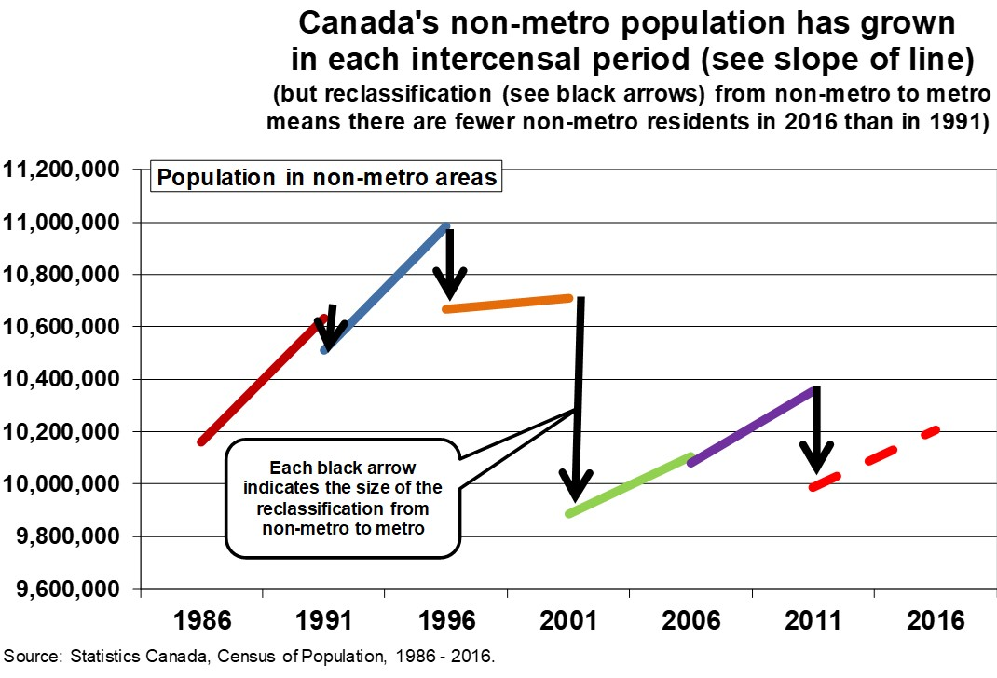

Similarly, the rural and small town (non-CMA/CA) population increased in every inter-censal period (except 1996 to 2001) (Figure 8).

However, and the rural and small town population was lower in 2016 than in 1966 (Figure 9) – again due to some growing rural and small town places becoming re-classified as part of a CMA or CA over time.

Figure 8. Five-year Change in Population in CMA, CA and Rural and Small Town areas, Canada, 1966 to 2016

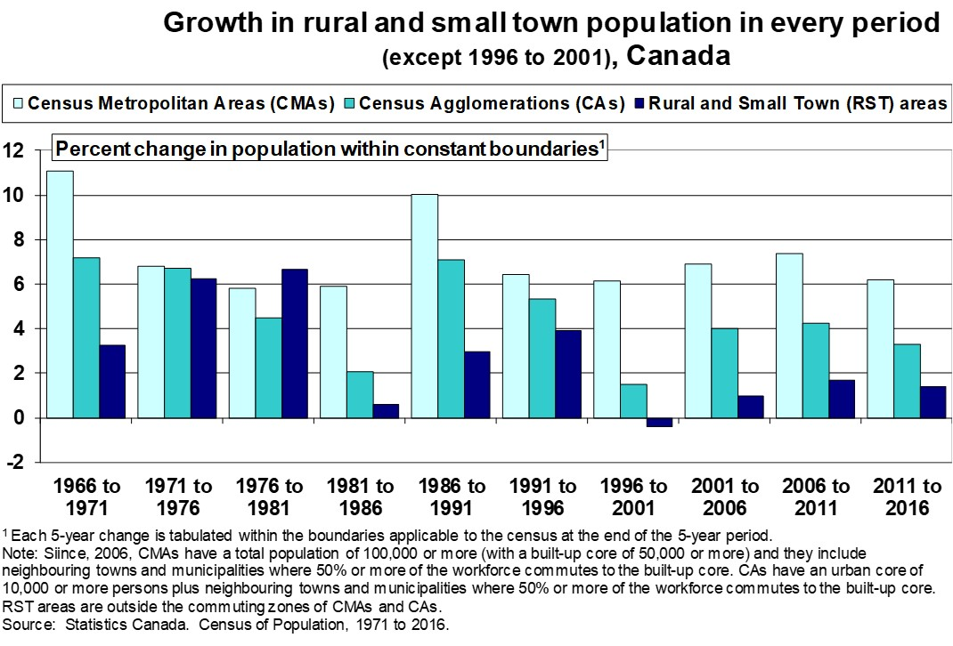
Figure 9. Population in CMAs, CAs and Rural and Small Town Areas, Canada, 1966 to 2016

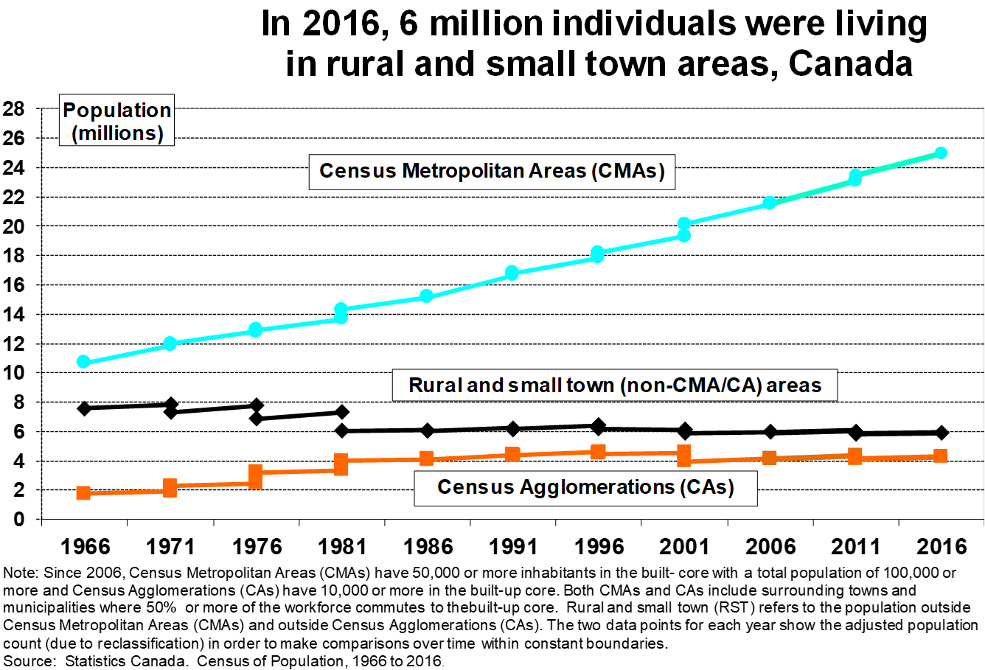

Annual Demographic Estimates

Statistics Canada generates annual population estimates for each census subdivision.

The methodology for developing the estimates is shown in:

Statistics Canada. (2021) Methodology / Notice to users: Annual postcensal population, Census subdivisions, Canada (Ottawa: Statistics Canada, Centre for Demography, January).

Annual estimates of population for each census subdivision from 2001 to 2022 (based on 2016 census subdivision boundaries) are available at
https://www150.statcan.gc.ca/t1/tbl1/en/cv.action?pid=1710014201

Annual estimates of population for each census subdivision from 2001 to date (based on 2021 boundaries) are available in Table 17-10-0155-01 at https://www150.statcan.gc.ca/t1/tbl1/en/cv.action?pid=1710015501.

Population projections for census divisions and census subdivision from 2025 to 2050 by gender and by 5-year age groups are available in

Table 17-10-0162-01: Projected population for census divisions and census subdivisions (2021 boundaries) by projection scenario, age and gender. (https://www150.statcan.gc.ca/t1/tbl1/en/tv.action?pid=1710016201).

Users my choose from 10 different projection scenarios based on your best guess of future demographic factors.

The methodology is described in:
Statistics Canada. (2026) Population Projections for Census Divisions and Subdivisions, 2025 to 2050: Technical Report (Ottawa: Statistics Canada, Catalogue no. 17-20-0003). https://www150.statcan.gc.ca/n1/pub/17-20-0003/172000032026003-eng.htm)

Importantly, and perhaps obviously, since CSDs are geographic building blocks for other classifications of rural (see Table 1), then annual population data can be generated for each of these classifications of rural by adding across the CSDs included in each classification. Recall that the CSDs including in each classification can be obtained from GeoSuite, noted above.

See also:

Annual demographic estimates, rural and small town and functional urban areas (i.e., CMA/CA areas): Interactive dashboard at https://www150.statcan.gc.ca/n1/pub/71-607-x/71-607-x2021030-eng.htm?utm_source=mstatcan&utm_medium=eml&utm_campaign=statcan-statcan-mstatcan

Annual demographic estimates, census metropolitan areas and census agglomerations: Interactive dashboard (https://www150.statcan.gc.ca/n1/pub/71-607-x/71-607-x2020003-eng.htm).

Annual demographic estimates, economic regions: Interactive dashboard (https://www150.statcan.gc.ca/n1/pub/71-607-x/71-607-x2020020-eng.htm).

Annual demographic estimates, census divisions: Interactive dashboard (https://www150.statcan.gc.ca/n1/pub/71-607-x/71-607-x2020021-eng.htm)

At the census division level, you can see annual estimates of the components of population change from 2001 to 2025 in Table 17-10-0153-01. Specifically, for each single year of age, for five-year age groups and for each gender, the components of population change include births, deaths, immigrants, net emigration, emigrants, returning emigrants, net temporary emigration, net interprovincial migration, net intra-provincial migration, net non-permanent residents and residual deviation. Note that annual population estimates are fixed at July 1st of each year and thus the components of population change refer to the 12-month period from July 1st to June 30th.

Labour Force Survey

The Labour Force Survey (LFS) is a monthly survey of individuals in the (potential) labour force (i,e., all individuals15 years of age and older). For a complete list of the information collected on the LFS, see

Statistics Canada. (2025) Guide to the Labour Force Survey: 2025 (Ottawa: Statistics Canada, Catalogue no. 71-543-G). ( https://www150.statcan.gc.ca/n1/pub/71-543-g/71-543-g2025001-eng.htm).

- Data for Rural and Small Town Areas

For each month starting in January, 2011, for each province, the Labour Force Survey publishes selected data for:

A: Total urban and rural areas
B: Census Metropolitan Areas and Census Agglomerations
B1: Urban core
B2: Urban fringe
B3: (Census) Rural fringe
C: Non-Census Metropolitan Areas and Non-Census Agglomerations (often labelled as “Rural and Small Town Canada” (RST))
C1: Small towns
C2: (Census) Rural areas

Note that data for all (census) rural areas can be generated by combining the workforce in the CMA/CA “(census) rural fringe” plus the workforce in RST “(census) rural areas”.

Table 14-10-0376-01 uses this classification to show employment by Class of Worker (i.e., employees or self-employed) and for 16 industry sectors (NAICS: North American Industry Classification System). See https://www23.statcan.gc.ca/imdb/p3VD.pl?Function=getVD&TVD=1369825).

These data are also presented in an Interactive Dashboard showing “Employment by industry in rural Canada” (see https://www150.statcan.gc.ca/n1/pub/71-607-x/71-607-x2021006-eng.htm). Notably, they use the terminology “Rural and Small Town Canada” for “Non-Census Metropolitan Areas and Non-Census Agglomerations” and they use the terminology “Functional Urban Areas” for “Census Metropolitan Areas and Census Agglomerations”.

For the same geographical units, Table 14-10-0374-01 shows employment by gender and by age group.

Data from these two tables formed the basis of a discussion of the impact of COVID-19 on rural labour markets in a 2021 paper:

Bollman, Ray D. (2021) “COVID-19 and the differential impacts on the rural and urban economies.” Journal of Rural and Community Development Vol. 16, No. 4, pp. 245 – 298 (https://journals.brandonu.ca/jrcd/article/view/2063).

Figure 10 shows the drop in the absolute number employed in manufacturing in Ontario’s CMA/CA areas and rural and small town areas in the middle of the COVID-19 epidemic. (Note to Ray - - - find the percent decline)

Figure 10. Employment in Manufacturing in Larger Urban Centres (CMAs and CAs) and in Rural and Small Town Areas, Ontario, 2014 to 2021

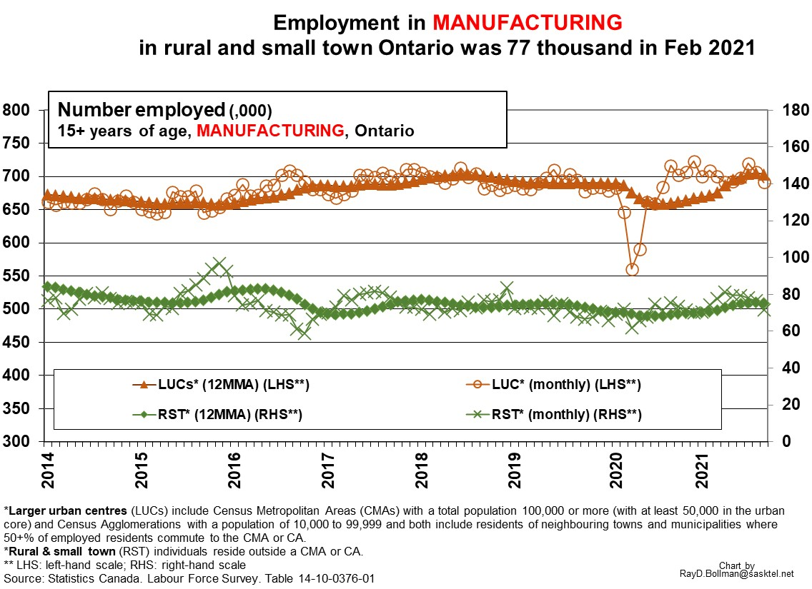

There is an opportunity to extend the analysis of this paper. I looked at the change in urban and rural employment rates (i.e., the percent of the potential labour force that was employed). However, COVID-19 had an additional impact on rural areas due to the movement of individuals from urban to rural areas. Thus, an interesting analysis could look at the total impact of COVID-19 on the rural economy by disaggregating the total change in rural employment into the components of
- the change in the number of individuals in the potential labour force; and
- the change in the employment rate of individuals residing in rural and small town areas.

Rural employment data starting in 2001 is in CANSIM Table 282-0098 and employment date starting in 2006 is in Table 282-0129 but these tables are not archived on the Statistics Canada webpage (but I can send along the data items that I have downloaded to my computer).

- Data for Self-contained Labour Areas

An alternative portrayal of rural employment is the published data for “self-contained labour areas” (SLAs). Table 14-10-0480-01at https://www150.statcan.gc.ca/t1/tbl1/en/tv.action?pid=1410048001 provides monthly data since January 2021.

An interactive dashboard is available at 71-607-X2024025 (https://www150.statcan.gc.ca/n1/pub/71-607-x/71-607-x2024025-eng.htm)

The methodology to generate the LFS data for each SLA is shown in:

Verret, François, Braedan Walker, Cynthia Bocci and Jean-François Beaumont. (2024) Small Area Estimation Methodology Using Labour Force Survey Data (Ottawa: Statistics Caada, Labour Statistics: Technical Papers, Catalogue no. 75-005-M)

The announcement of the initial publication of these data was at
https://www150.statcan.gc.ca/n1/daily-quotidien/240917/dq240917d-eng.htm

- Data for Economic Regions

The Labour Force Survey also publishes monthly data for economic regions which are composed of one or more census divisions. At the Statistics Canada DATA page, the “economic region” option in the list of geographic units indicates that there are 75 tables showing data by economic region - - - and some of those tables show LFS data

Data for economic regions are used to determine both the amount and duration of Employment Insurance (EI) payouts. The current unemployment rate in a claimant's specific economic region is a key factor in the calculation.

For a definition of economic regions, see https://www12.statcan.gc.ca/census-recensement/2021/ref/dict/az/definition-eng.cfm?ID=geo022.

Statistics Canada’s Standard Geographical Classification Manual describes census divisions and economic regions (https://www.statcan.gc.ca/en/subjects/standard/sgc/2021/introduction)

There is a map of economic regions and their component census divisions at https://www12.statcan.gc.ca/census-recensement/2021/geo/maps-cartes/referencemaps-cartesdereference/sgc-cgt/files-fichiers/2021-12572-01-D.pdf.

Annual estimates of Gross Domestic Income for each economic region are available at https://www150.statcan.gc.ca/n1/pub/71-607-x/71-607-x2021023-eng.htm. The most recent announcement of these data was in Statistics Canada’s “The Daily” at https://www150.statcan.gc.ca/n1/daily-quotidien/250505/dq250505a-eng.htm where they note that the complete dataset is available upon request.

Rural Canada Business Profiles

- Data for rural and small town Canada

There is a Rural Canada Business Profiles: Interactive Dashboard at https://www150.statcan.gc.ca/n1/pub/71-607-x/71-607-x2024001-eng.htm.

Description and definitions in the database are documented in:

Statistics Canada. (2025) Rural Canada Business Profiles Metadata and User Guide, 2023 (Ottawa: Statistics Canada, Catalogue no. 45-20-0004). (https://www150.statcan.gc.ca/n1/pub/45-20-0004/452000042025003-eng.htm) provides

The published data is comprised of:

- Seven tables regarding small businesses with a revenue-based calculation:
Table 33-10-0577-01: Rural Canada Business Profile, total revenue and other revenue variables of small businesses by industry, location indicator and incorporation status; revenue-based calculations
Table 33-10-0578-01: Rural Canada Business Profile, expense items as a percent of total revenue of small businesses by industry, location indicator and incorporation status; revenue-based calculations
Table 33-10-0579-01: Rural Canada Business Profile, expense items of small businesses by industry, location indicator and incorporation status; revenue-based calculations
Table 33-10-0580-01: Rural Canada Business Profile, balance sheet items of incorporated small businesses by industry and location indicator; revenue-based calculations
Table 33-10-0581-01: Rural Canada Business Profile, financial ratios of incorporated small businesses by industry and location indicator; revenue-based calculations
Table 33-10-0582-01: Rural Canada Business Profile, financial ratios of small businesses by industry, location indicator and incorporation status; revenue-based calculations
Table 33-10-0583-01: Rural Canada Business Profile, business items for profitable and non-profitable small businesses by industry and location indicator; revenue-based calculations

- Seven tables regarding small businesses with a profit margin-based calculation
Table 33-10-0584-01: Rural Canada Business Profile, total revenue and other revenue variables of small businesses by industry, location indicator and incorporation status; profit margin-based calculations
Table 33-10-0585-01: Rural Canada Business Profile, expense items as a percent of total revenue of small businesses by industry, location indicator and incorporation status; profit margin-based calculations
Table 33-10-0586-01: Rural Canada Business Profile, expense items of small businesses by industry, location indicator and incorporation status; profit margin-based calculations
Table 33-10-0587-01: Rural Canada Business Profile, balance sheet items of incorporated small businesses by industry and location indicator; profit margin-based calculations
Table 33-10-0588-01: Rural Canada Business Profile, financial ratios of incorporated small businesses by industry and location indicator; profit margin-based calculations
Table 33-10-0589-01: Rural Canada Business Profile, financial ratios of small businesses by industry, location indicator and incorporation status; profit margin-based calculations
Table 33-10-0590-01: Rural Canada Business Profile, business items for profitable and non-profitable small businesses by industry and location indicator; profit margin-based calculations

- Five tables regarding medium-sized businesses with a revenue-based calculation:
Table 33-10-0591-01: Rural Canada Business Profile, total revenue and other revenue variables of incorporated medium businesses by industry and location indicator; revenue-based calculations
Table 33-10-0592-01: Rural Canada Business Profile, expense items as a percent of total revenue of incorporated medium businesses by industry and location indicator; revenue-based calculations
Table 33-10-0593-01: Rural Canada Business Profile, expense items of incorporated medium businesses by industry and location indicator; revenue-based calculations
Table 33-10-0594-01: Rural Canada Business Profile, balance sheet items of incorporated medium businesses by industry and location indicator; revenue-based calculations
Table 33-10-0595-01: Rural Canada Business Profile, financial ratios of incorporated medium businesses by industry and location indicator; revenue-based calculations

- Five tables regarding medium-sized businesses with profit margin-based calculation:
Table 33-10-0596-01: Rural Canada Business Profile, total revenue and other revenue variables of incorporated medium businesses by industry and location indicator; profit margin-based calculations
Table 33-10-0597-01: Rural Canada Business Profile, expense items as a percent of total revenue of incorporated medium businesses by industry and location indicator; profit margin-based calculations
Table 33-10-0598-01: Rural Canada Business Profile, expense items of incorporated medium businesses by industry and location indicator; profit margin-based calculations
Table 33-10-0599-01: Rural Canada Business Profile, balance sheet items of incorporated medium businesses by industry and location indicator; profit margin-based calculations
Table 33-10-0600-01: Rural Canada Business Profile, financial ratios of incorporated medium businesses by industry and location indicator; profit margin-based calculations

See https://www150.statcan.gc.ca/n1/pub/45-20-0004/452000042025003-eng.htm.

Canadian Survey of Business Conditions

The quarterly Survey of Business Conditions was started in March, 2020 to collect information on emerging issues facing businesses in Canada. (https://www23.statcan.gc.ca/imdb/p2SV.pl?Function=getSurvey&Id=1582283)

The survey focuses both on business conditions and business expectations.

The results from the most recent Canadian Survey of Business Conditions was announced in Statistics Canada’s The Daily on Friday, February 27th. See https://www150.statcan.gc.ca/n1/dai-quo/index-eng.htm and the report is available at (https://www150.statcan.gc.ca/n1/daily-quotidien/260227/dq260227c-eng.htm?utm_source=mstatcan&utm_medium=eml&utm_campaign=statcan-statcan-mstatcan)

- Data for rural and small town areas

At the Statistics Canada DATA page, within the category of “Survey or Statistical Program”, one sees that there are 663 tables of results from the “Canadian Survey of Business Conditions”. In each of these tables, in the category of “Business Characteristics” (i.e., not in the category of “Geography”), you will see a category labelled “Geography” and within that group, there are two choices: “urban” and “rural”. In this case, “urban” refers to CMA /CA areas and “rural” refers to non-CMA/CA areas (i.e., rural and small town areas).

On February 27th, another 41 tables were published, each with a rural<>urban variable embedded in the “Business Characteritis” tab.

Also, business conditions for rural and small town (Non-CMA/CA) Canada are displayed in an interactive dashboard at https://www150.statcan.gc.ca/n1/pub/71-607-x/71-607-x2024009-eng.htm.

Also, there are 10 Rural and Small Town Canada Analysis bulletins that have discussed the results from the Canadian Survey of Business Conditions from the first quarter of 2020 to the first quarter of 2025. See https://www150.statcan.gc.ca/n1/en/catalogue/21-006-X#wb-auto-2.

As a suggestion to future analysts, may I suggest, in addition to showing the percent of businesses reporting a given situation, that you also show a location quotient to show the relative size of the given situation in rural areas. For one example, see

“Business conditions in rural Ontario, 3rd quarter of 2020” (Special Issue, February 18, 2021) (https://www.ruralontarioinstitute.ca/uploads/userfiles/files/2021%20Feb18%20Business%20conditions%20in%20rural%20Ontario%203rd%20quarter%20of%202020.pdf)

See also

Smailes, Marina, Anne Munro, Andrew Balcom, Stephen Fudge and Haaris Jafri. (2021) Outlook of rural businesses and impacts related to COVID-19, first quarter of 2021. (Ottawa: Statistics Canada, StatCan COVID-19: Data to Insights for a Better Canada, Catalogue no. 45280001) (https://www150.statcan.gc.ca/n1/pub/45-28-0001/2021001/article/00015-eng.htm).

Balcom, Andrew, Darren Ytsma, Segun Odunage, Marina Smailes and Christopher Cottin. (2021) Outlook of rural businesses and impacts related to COVID-19, third quarter of 2021. (Ottawa: Statistics Canada, StatCan COVID-19: Data to Insights for a Better Canada, Catalogue no. 45-28-0001) (https://www150.statcan.gc.ca/n1/pub/45-28-0001/2021001/article/00038-eng.htm).

Balcom, Andrew, Anne Munro, Darren Ytsma and Eric Baxter. (2022) The outlook of rural businesses, fourth quarter of 2021. (Ottawa: Statistics Canada, StatCan COVID-19: Data to Insights for a Better Canada, Catalogue no. 45-28-0001) (https://www150.statcan.gc.ca/n1/pub/45-28-0001/2022001/article/00001-eng.htm).

Also, with this survey, the methodology to generate estimates of remote work opportunities within each self-contained labour area in Canada is evaluated in:

Yu Su, Stanley. (2024) Enhancing data for rural Canada: Small area estimation of remote work opportunities (Ottawa: Statistics Canada, Reports on Small Business Projects, Catalogue no. 18-001-X).

Business openings and business closures

Statistics Canada publishes experimental estimates of business openings and business closures for each province and each Census Metropolitan Area (CMA).

See Table 33-10-0270-01: Experimental estimates for business openings and closures for Canada, provinces and territories, census metropolitan areas, seasonally adjusted. See (https://www150.statcan.gc.ca/t1/tbl1/en/tv.action?pid=3310027001).

The methodology is documented in:

Lafrance-Cooke, Amelie, Ryan Macdonald and Michael Willox. (2020) Monthly Business Openings and Closures: Experimental Series for Canada, the Provinces and Territories, and Census Metropolitan Areas (Ottawa: Statistics Canada, Economic Insights, Catalogue no. 11-626-X — 2020014 - No. 116). (https://www150.statcan.gc.ca/n1/en/catalogue/11-626-X2020014)

One result showed that the number of active businesses in Ontario fell by the same rate from February 2020 to April 2020 in Metro (CMA) areas and in Non-metro (Non-CMA) areas (Figure 11).

Figure 11. Number of Active Businesses, Ontario, 2017 to April, 2020

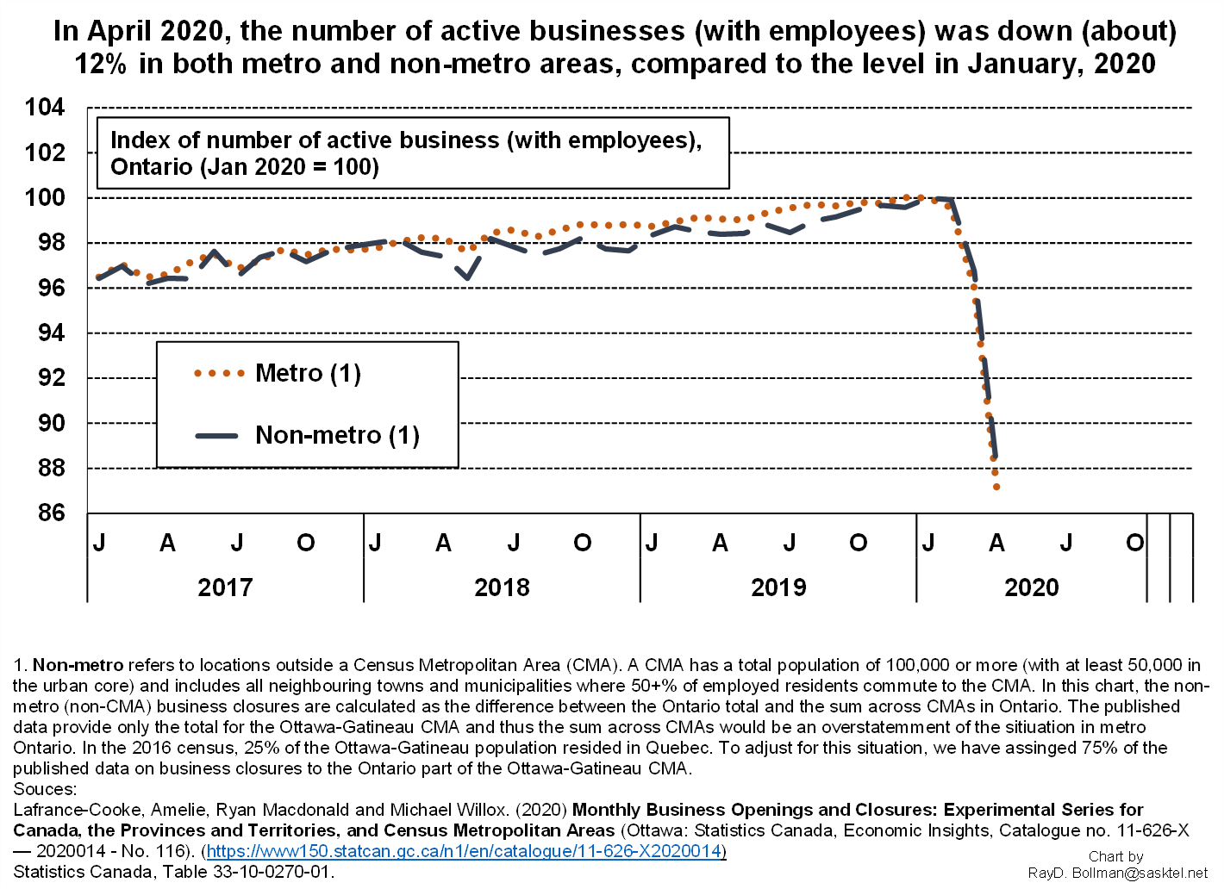

Canadian Social Survey

At the Statistics Canada DATA page, under the heading of “Survey or Statistical Program’, the entry for the “Canadian Social Survey” lists 49 tables. About half of these tables provide data for urban and for rural areas.

A map showing “Quality of Life Indicators by census subdivision and by census division is shown at https://gaia.statcan.gc.ca/csge/infc/app/index-qol-en.html.

Be sure to read the “limitations” such as:
each well-being indicator was based on pooled estimates across multiple waves of the Canadian Social Survey. Different geographic areas were not surveyed equally in every wave of the Canadian Social Survey, therefore well-being indicators in some geographic areas may be more heavily biased toward certain years and seasons than others. Well-being indicators such as life satisfaction have been observed to change from one collection period to the next. There are also potential seasonal influences on how respondents answer survey questions. These factors may explain some of the variation across geographic areas.

If you scroll to the bottom, they define “urban” and “rural” areas as:

Urban and rural areas
“Urban areas” are defined as all areas that are inside of census metropolitan areas (CMAs) and census agglomerations (CAs). “Rural areas” are defined as all areas that are outside of CMAs and CAs. The CMA and CA definitions are based on Statistics Canada’s 2016 Standard Geographical Classification (SGC).

The tables listed below show the data by “other selected sociodemographic statistics”. One of those selected statistics is “urban” and “rural” using the CMA/CA vs non-CMA/CA classification noted above

Table 13-10-0844-01: Life satisfaction by gender and other selected sociodemographic characteristics

Table 13-10-0846-01: Sense of meaning and purpose by gender and other selected sociodemographic characteristics

Table 13-10-0848-01: Future outlook by gender and other selected sociodemographic characteristics

Table 45-10-0070-01: Satisfaction with local environment, by gender and other selected sociodemographic characteristics

Table 45-10-0049-01: Loneliness by gender and other selected sociodemographic characteristics

Table 45-10-0051-01: Having someone to count on by gender and other selected sociodemographic characteristics

Table 45-10-0053-01: Sense of belonging to local community by gender and other selected sociodemographic characteristics

Table 45-10-0068-01: Satisfaction with time use for preferred activities, by gender and other selected sociodemographic characteristics

Table 45-10-0074-01: Confidence in institutions, by gender and other selected sociodemographic characteristics

Table: 45-10-0078-01: Sense of belonging to Canada, by gender and other selected sociodemographic characteristics

Table 45-10-0091-01: Satisfaction with family relationships by gender and other selected sociodemographic characteristics

Table 45-10-0093-01: Satisfaction with friend relationships by gender and other selected sociodemographic characteristics

Table 45-10-0099-01: General trust in others by gender and other selected sociodemographic

Table 45-10-0101-01: Discrimination and unfair treatment by gender and other selected sociodemographic characteristics

Table 45-10-0097-01: Trust in news or information from media by gender and other selected sociodemographic characteristics

Table 45-10-0103-01: Trust in media and main source of news by gender and other selected sociodemographic characteristics

Table 45-10-0080-01: Perceived mental health, by gender and other selected sociodemographic characteristics

Table 45-10-0082-01: Perceived health, by gender and other selected sociodemographic characteristics

Table 45-10-0095-01: Trust in people by gender and other selected sociodemographic characteristics

Table 45-10-0076-01: Trust in others, by gender and other selected sociodemographic characteristics

Table 45-10-0089-01: Job satisfaction, by gender and other selected sociodemographic characteristics

Table 45-10-0072-01: Satisfaction with personal relationships, by gender and other selected sociodemographic characteristics

Table 45-10-0089-01: Job satisfaction, by gender and other selected sociodemographic characteristics

Table 45-10-0087-01: Difficulty meeting financial needs, by gender and other selected sociodemographic

Table 45-10-0049-01 Loneliness by gender and other selected sociodemographic characteristics

Table 23-10-0313-01: Access to public transport by distance and public transport carrying capacity, geography, gender, and selected demographic and socio-economic characteristics al

In the above table, the “location” tab shows “urban” and “rural”, defined as

The boundaries of urban and rural areas are delineated using the Statistics Canada 2021 Census of Population definition of rural areas

Specifically, here, “urban” refers to population centres with a population of 1,000 or more and “rural” refers to (census) rural which refers to residents outside population centres

Table 46-10-0074-01: Persons in core housing need, by tenure and other selected sociodemographic characteristics

In this case, within the “sociodemographic characteristics”, there is a category for “population centres” (i.e., centres with a population of 1,000 or more) with three subcategories (large urban population centres, medium population centres and small population centres) and a category for rural areas (i.e. outside centres with a population of 1,000 or more).The footnotes state that “Large urban population centres” have a population of 100,000 or more” and “Medium population centres” have a population between 30,000 and 99,999” and “Smal population centres” have a population between 1,000 and 29,999)

Similarly for Table 46-10-0072-01: Persons living in acceptable housing, by tenure and other selected sociodemographic characteristics

Also, see

Foran, Helen. (2025) Community and well-being: Exploring sense of belonging among youth (Ottawa: Statistics Canada, Catalogue no. 75-006). (https://www150.statcan.gc.ca/n1/en/pub/75-006-x/2025003/article/00001-eng.pdf?st=88h6NEH6)

Thomson, Myfanwy, Maire Sinha, Simen Hemm and Lauren Pinault. (2025) Beyond urban and rural: Rethinking the social geography of Canada (Ottawa: Statistics Canada, Insights on Canadian Society, Catalogue number 75-006) (https://www150.statcan.gc.ca/n1/pub/75-006-x/2025002/article/00003-eng.htm).

Employment Insurance Statistics - Monthly (EIS)

- Data for rural and small town areas

Statistics Canada publishes monthly data employment insurance beneficiaries from the Employment Insurance Program operated by Employment and Social Development Canada (https://www23.statcan.gc.ca/imdb/p2SV.pl?Function=getSurvey&SDDS=2604)

See the interactive dashboard: Employment Insurance Beneficiaries in Rural and Small Town Canada released on Jan. 27, 2026 (https://www150.statcan.gc.ca/n1/daily-quotidien/260127/dq260127e-eng.htm?utm_source=mstatcan&utm_medium=eml&utm_campaign=statcan-statcan-mstatcan).

Building permits

- Data for rural and small town areas

In the Rural Canada Housing Profiles, the annual data show the number and value of residential building permits by type of residential building and type of construction work, for each census subdivision and there is a “location indicator” that classifies the data for CMA/CA areas (labelled as “Functional Urban Areas”) and non-CMA/CA areas (labelled as “Rural and Small Town Areas”) in Table: 46-10-0087-01 (https://www150.statcan.gc.ca/t1/tbl1/en/cv.action?pid=4610008701).

An Interactive Dashboard for the Rural Canada Housing Profiles (https://www150.statcan.gc.ca/n1/pub/71-607-x/71-607-x2023023-eng.htm) shows a chart of the selected variables at the top and below the charts, the data is shown for the selected variables.

Building permits, by type of structure and type of construction work are available for each province and for each CMA and, thus by calculation, one can obtain the monthly data for non-CMA areas in each province. See Table 34-10-0292-01 at (https://www150.statcan.gc.ca/t1/tbl1/en/tv.action?pid=3410029201.)

Trade: Exports and Imports of Goods

- Data for rural and small town areas

The Trade in Rural and Small Town Canada Interactive Dashboard (https://www150.statcan.gc.ca/n1/pub/71-607-x/71-607-x2024010-eng.htm) shows annual data for the number of establishments and the value the value of shipments for each industrial sector in CMA/CA areas (labelled as “Functional Urban Areas”) and for non-CMA/CA areas (labelled as “Rural and Small Town Areas”).

Definitions and data sources are provided in “Rural Canada Trade Profiles Metadata and User Guide, 2024” at https://www150.statcan.gc.ca/n1/pub/45-20-0004/452000042025002-eng.htm.

Non-profit organizations

- Data for rural and small town Canada

The non-profit database provides information on the number of organizations, revenues, and number of employees for non-profit organizations in Canada. The data are available by type of activity of the organization and by industry group (based the North American Industry Classification System (NAICS)).

See https://www150.statcan.gc.ca/n1/pub/45-20-0004/2025001/meta-eng.htm.

See also the Rural Canada Non-profits: Interactive Dashboard at https://www150.statcan.gc.ca/n1/pub/71-607-x/71-607-x2023019-eng.htm.

Health of Canadians

- Data for Health Regions

At the Statistics Canada DATA page, there are 21 tables showing data by health regions. I expect someone somewhere has assigned a degree of rurality to each health region.

Statistics Canada has allocated each health region to a “peer group”:

Statistics Canada. (2025) Health Region Peer Groups: Working paper, 2024 (Ottawa: Statistics Canada, Catalogue no. 82-622-X) (https://www150.statcan.gc.ca/n1/en/pub/82-622-x/82-622-x2025001-eng.pdf?st=8S96RjS0).

On the Statistics Canada DATA page, in the geography list, there are 7 tables with data for peer group. Perhaps obviously, some peer groups are more ‘rural’ than others - - - such as peer groups based on small cities or peer groups of remote health regions. When you open one of these tables, click on “geography” to see the list of health regions and if you scroll to the bottom of the list of health regions, you will see a list of peer groups. Then you can compare the results of your health region with the data for comparable health regions (i.e., your peer group).

Canada Emergency Business Account (CEBA)

- Data for rural and small town areas

Also, there are data tables related to Canada Emergency Business Account (CEBA) loans. Go to the Statistics Canada DATA page and search on CEBA which will provide a list of 54 tables. The term “CEBA” is not evident in many of the tables but, as far as I can tell, all of the data relate to the COVID-19 period. In each of these tables, in the category of “Business Characteristics” (i.e., not in the category of “Geography”), you will see a category labelled “Geography” and within that group, there are two choices: “urban” and “rural”. In this case, “urban” refers to CMA /CA areas and “rural” refers to non-CMA/CA areas (i.e., rural and small town areas).

Canada Emergency Wage Subsidy Regional and Community-level Database

- Data for rural and small town areas

The Canada Emergency Wage Subsidy Regional and Community-level Database
(https://www150.statcan.gc.ca/n1/en/catalogue/11260003) has three versions of the database (released on March 18, 2020, on November 16, 2020 and on March 21, 2021). Go to the Statistics Canada DATA page and search on CEWS. (It appears that the 2nd version includes the observations in the 1st version plus updates to the date in the 1st version and then the 3rd version repeats this pattern with updates to the 2nd version – but I am not sure as the all the data in the 3rd version will not fit on my computer. There is an Urban-Rural flag where urban refers to CMAs and CAs and rural refers to rural and small town (non-CMA/CA) areas.

See
Statistics Canada. (2021) Rural insights from the Canada Emergency Wage Subsidy: October 25, 2020 to January 16, 2021(Ottawa: Statistics Canada, Catalogue no. 45-28-0001). (https://www150.statcan.gc.ca/n1/pub/45-28-0001/2021001/article/00040-eng.htm)

Bacon, Scott P., Ash Munro, Peter Timusk and Haaris Jafri. (2021) A closer look at the Canada Emergency Wage Subsidy: A rural lens (Ottawa: Statistics Canada, Catalogue no. 45-28-0001). (https://www150.statcan.gc.ca/n1/en/pub/45-28-0001/2021001/article/00024-eng.pdf?st=EqxYGweZ)

Rural Ontario Institute. (2021) “Canada Emergency Wage Subsidy (CEWS) support for Rural Businesses in Ontario, March 15, 2020 to January 16, 2021.” Focus on Rural Ontario (Guelph: Rural Ontario Institute) (http://www.ruralontarioinstitute.ca/knowledge-centre/focus-on-rural-ontario). (https://www.ruralontarioinstitute.ca/uploads/userfiles/files/CEWS%20support%20for%20rural%20businesses_%20Final-3.pdf?utm_source=ROI+Website&utm_campaign=Focus-On+Rural+Ontario).

Selected population characteristics within ecozones, ecoprovinces and ecoregions

See Table 38-10-0047-01: Selected population characteristics, Canada, ecozones, ecoprovinces and ecoregions

In this case, within the tab for “population characteristics”, there is a category for “population within population centres” (i.e., centres with a population 1,000 or more) and a category for (census) rural areas (i.e., outside population centres of 1,000 or more.

Gross Domestic Product for Non-metro (Non-CMA) areas

- Non-metro GDP

Statistics Canada publishes Gross Domestic Product (GDP) for each Census Metropolitan Area (CMA) in Canada. The non-metro GDP can be calculated by subtracting the GDP for each CMA from the province-level GDP.

The data used to calculate GDP per worker and GDP per capita tables are derived from the following tables:

Gross Domestic Product for each province and for each Census Metropolitan Area (CMA), Table 36-10-0468-01;
Population by Province, Table 17-10-0005-01;
Population for each Census Metropolitan Area, Table 17-10-0135-01;
Employment by Province, Table 14-10-0023-01; and
Employment by Census Metropolitan Area, Table 14-10-0385-01.

The calculations at the Canada-level are shown in (Table 6). (I can pass along my Excel tables for Canada and each province to anyone who is interested.)

In 2020, non-metro represented 28% of Canada’s population and 25% of Canada’s GDP (Figure 12).
Table 6. Gross Domestic Product, Employment and Population in Metro (CMA) Areas and in Non-metro (non-CMA) areas, Canada, 2009 to 2020

Figure 12. Size of Non-metro (non-CMA) Population and Size of Non-metro GDP, Canada, 2009 to 2020

- GDP in rural areas (calculated from a 1km by 1m grid), 2019

Brown et al. (2025) have applied an EU protocol to assign GDP to each 1km by 1km grid squares in Canada. They observe that, according to their delineation, rural areas in Canada produce about 23% of national Gross Domestic Product and about 23% of Canada’s population live in these rural areas (Table 7).

Table 7. Gross Domestic Product (GDP) and Population by a Density Dimension and a Distance-to-Density Dimension (calculated from a 1km by1km grid), Canada. 2019

See:
Brown, Mark, Matthew Brown, Jiang Li and Jesse Tweedie. (2025) Mapping the importance of urban and rural economies in Canada: Experimental grid square-based gross domestic product and gross domestic income (Ottawa: Statistics Canada, Economic and Social Reports, Catalogue no. 36-28-0001). (https://www150.statcan.gc.ca/n1/en/pub/36-28-0001/2025004/article/00003-eng.pdf?st=PrldDNsw)

Other data sources

For the data sources listed above, there is some published ‘rural’ data on the Statistics Canada website. Many of those data sources are also able to provide custom tabulations upon request.

There are other data source with no published ‘rural’ data but, again, a custom tabulation would generate rural data according to one’s specifications.

Also, some data sources provide a Public Use Microdata File (PUMF) for research analysts.

- General Social Survey

The General Social Survey (GSS) is able to generate custom tabulations and also has a PUMF for research analysts.

The GSS focuses on key social themes in rotating cycles, primarily tracking trends in well-being, social networks, and daily life. Main topics include caregiving, family structure, time use, social identity, victimization and volunteer participation.

For recent iterations of the GSS, researchers can access a Public Use Microdata File (PUMF) where each observation is coded as residing in a CMA/CA area or a non-CMA/CA (rural and small town) area.
- Time Use: 2022 (TU_ET 2022); 2015 (Cycle 29); 2010 (Cycle 24); 2005 (Cycle 19)
- Caregiving and care receiving: 2018 (Cycle 32) and 2012 (Cycle 26)
- Families: 2017 (Cycle 31); 2011 (Cycle 25); 2006 (Cycle 20), contains a modified LUC_RSTC (1= CMA/CA, 2=non-CMA/CA for Quebec, Ontario and British Columbia only, 3= Other provinces)
- Canadians at Work and Home: 2016 (Cycle 30)
- Victimization: 2014 (Cycle 28); 2011 (Cycle 23); 2004 (Cycle 18)
- Social networks/Social Engagement: 2010 (Cycle 22); 2003 (Cycle 17)
- Access to Use of Information Communication Technology: 2000 (Cycle 14) contains URIND (1=Urban, 2=Rural, 3=P.E.I.)

- Other surveys with PUMF files
Examples of PUMF files available from Statistics Canada, in addition to the GSS, are the Canadian Community Health Survey (CCHS), Canadian Health Survey on Seniors (CHSS), Survey of Household Spending (SHS), Canadian Income Survey (CIS), National Graduates Survey (NGS), Canadian Internet Use Survey (CIUS) plus the Census of Population (2021, 2016, 2011/NHS). Note, however, only some of these files will have an indicator of sub-provincial geography.

- Indigenous Peoples Survey

The Indigenous Peoples Survey of 2022 collected data for Indigenous people living off reserves and published data on the access to the Internet for residents of (census) rural areas and for three size classes of population centres. (See Table 41-10-0077-01 Access to Internet by population centre size, First Nations people living off reserve, Métis and Inuit.)

Appendix A: Selected notes regarding Statistics Canada

Each day, Statistics Canada publishes a document called “The Daily” which lists each document and each data series that is released on the current day (See https://www150.statcan.gc.ca/n1/dai-quo/index-eng.htm). You may subscribe to “The Daily” by first going to the Statistics Canada login page https://www.statcan.gc.ca/msc/en/mystatcan/login to log in and then follow the prompts. You can receive The Daily which announces everything published on a given day or you can subscribe to receive an announcement for only selected topics (e.g., rural topics).

Statistics Canada has a series of lessons / videos on "Assessing Data in a Time of Misinformation: A Step by Step Guide" to help policymakers and other decision makers verify the quality, credibility and relevance of any statistic or information source. A short companion video titled "Fighting Misinformation" also demonstrates how to apply these checks in practice, from questioning suspect figures to confirming that data truly meet reliability standards. Both resources are available through the Data Literacy Training Learning catalogue. (See https://www.statcan.gc.ca/en/wtc/data-literacy/catalogue)

Statistics Canada has a podcast called “The Eh Sayers Podcast” at https://www150.statcan.gc.ca/n1/en/catalogue/45200003.

Thematic maps can be viewed at https://www12.statcan.gc.ca/census-recensement/2021/geo/maps-cartes/index-eng.cfm. Specifically, thematic maps display selected socio-economic indicators at the CSD level. See https://www150.statcan.gc.ca/n1/en/catalogue/92-173-X.

Statistics Canada - Data Visualization Products
(https://www150.statcan.gc.ca/n1/en/catalogue/71-607-X)

Appendix B: Quotation in the January, 2026 issue of “The Rural Roundup”

Rural communities have a significant role to play in Canada’s new economic future, says Buckley Belanger, Secretary of State for Rural Development.

“Rural Canada accounts for 13 per cent of our national population, and yet they contribute 27 per cent of the GDP we enjoy as a country,” Buckley told CBC recently.

“So rural Canada is really doing their part.”

Another quiz:

“If” Rural Canada encompasses 13% of the population and generates 27% of the GDP, this means that the rural GDP per capita is about double the national GDP per capita - - - right?

Situation:

- Canada’s (census) rural population represented 19% of Canada’s total population in 2016 (see Figure 6 above). (I am not sure of the source of the 13% quoted above).
- Canada’s non-metro (non-CMA) population contributed 29% of Canada’s total GDP in 2016 (see Figure 12 above).
- But . . . This is a comparison of two different groups of individuals being classified as “rural”.
- “If” one compares the population and the GDP for the same group of individuals being classified as rural, we find that the “rural” share of Canada’s population and the “rural” share of Canada’s GDP is about the same (for two different ways of defining “rural”, see Figure 12 and Table 7 above).
- So, yes, “rural Canada is doing their part”.

Figure 13 Hierarchy of Standard Geographic Areas for Dissemination for 2021 Census of Population
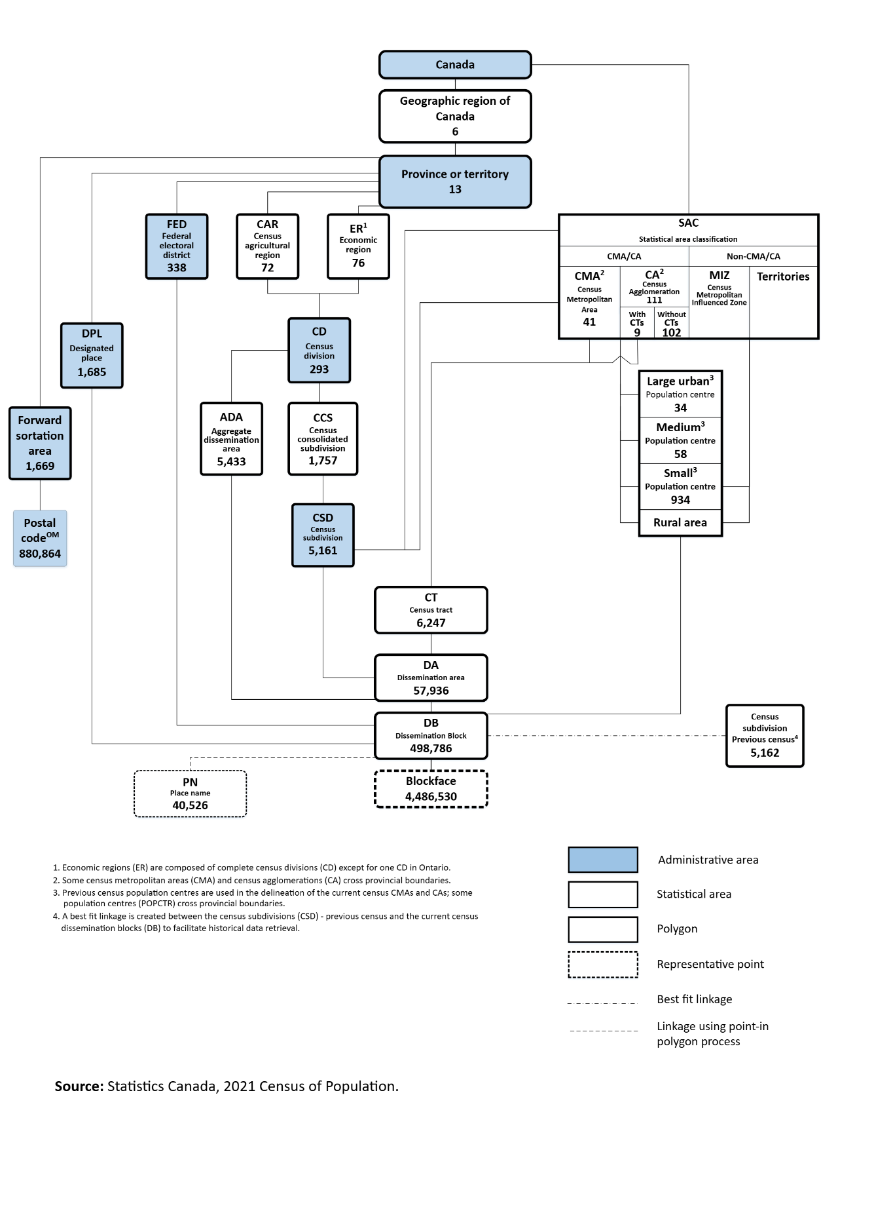
Source: (https://www12.statcan.gc.ca/census-recensement/2021/ref/dict/fig/index-eng.cfm?ID=F1_1)
Stuff under review

Census data tests “What everyone knows!”

Everyone knows that rural schools have more teacher turnover and younger, less experienced teachers

A recent OECD report emphasizes the changing demand for rural data that requires measures of well-being and measures of perceived well-being.

OECD (2025) Reinforcing Rural Resilience (Paris: OECD) https://www.oecd.org/en/publications/reinforcing-rural-resilience_7cd485e3-en.html#executive-summary)

At the Statistics Canada DATA page, if you search for “population centres”, in some cases, you will also see data for (census) rural areas.

For example:

Table: 13-10-0973-01Health characteristics, two-year period estimates, census metropolitan areas and population centres

Table: 32-10-0396-01 Farm population and total population for rural areas and population centres classified by gender and age, Agriculture–Population Linkage, 2021

Table: 13-10-0875-01 Socioeconomic characteristics of the transgender and non-binary population, 2019 to 2021

Table: 14-10-0374-01 Employment and unemployment rate, monthly, unadjusted for seasonality

Table: 45-10-0087-01 Difficulty meeting financial needs, by gender and other selected sociodemographic characteristics

Table: 46-10-0072-01 Persons living in acceptable housing, by tenure and other selected sociodemographic characteristics

Table: 17-10-0117-01 Selected population characteristics, Canada, major drainage areas and sub-drainage areas

Table: 11-10-0241-01 Low income cut-offs (LICOs) before and after tax by community size and family size, in current dollars, 1976 to 2023

Table: 13-10-0805-01 Health characteristics, two-year period estimates, census metropolitan areas and population centres

Table: 35-10-0052-01 Annual admissions (number, percent) to residential facilities for victims of abuse, by resident type and area density (i.e., population centres and (census) rural areas)

Table: 35-10-0178-01 Incident-based crime statistics, by detailed violations, police services in the Atlantic provinces

Table: 35-10-0186-01 Crime severity index and weighted clearance rates, police services in the Atlantic provinces

(Note: For “police services”. there is a separate table for each province.)
(Note: The ‘geography” of each police service often covers both rural and urban

Lu, Chaohui, Grant Schellenberg and Feng Hou. (2015) How’s Life in the City? Life Satisfaction Across Census Metropolitan Areas and Economic Regions in Canada (Ottawa: Statistics Canada, Economic Insights No. 46, Catalogue no. 11-626) (http://www.statcan.gc.ca/pub/11-626-x/11-626-x2015046-eng.htm).

See also the (CSD) Municipal Quality of Life Dashboard at (https://www150.statcan.gc.ca/n1/pub/71-607-x/71-607-x2023025-eng.htm) which is generated from data collected in the 2021 Census of Population.

Thanks to the Canadian Rural Revitalization Foundation (www.crrf.ca) for the invitation to present this webinar. CRRF has been active in rural research and rural advocacy since 1989. Their annual rural policy conferences (since 1989) is one piece of evidence of this activity. Also, their occasional “State of Rural Canada Reports) (5 reports since 2015) have provided in-depth discussions on all aspects of rural livelihoods and rural policy (see www.sorc.crrf.ca).
For example, see Main, Hannah, Sarah-Patricia Breen, Danielle Collins, Valencia Gaspard, Brennan Lowery, Sarah Minnes and Bill Reimer (ed). (2019) State of Rural Canada III: Bridging Rural Data Gaps (Guelph: Canadian Rural Revitalization Foundation) (www.sorc.crrf.ca)
For example, for some classifications, commuting flows are used in the classification. One can get a strange result if the boundary between two geographical units is the “Main Street” in your town. In this case, folks living on one side of Main Street and working on the other side of Main Street are classified as “commuters”. This is but one example of the need to dig into the nitty-gritty. Caveat emptor.
Our discussion focuses solely on the different ways of classifying ‘rural’ and ‘urban’ used in reports from Statistics Canada. Other federal departments and agencies, research institutes and many provinces often use different urban and rural classifications for their analytic reports and for program delivery.
A detailed schematic of the various geographic units is shown in Appendix B.
A dissemination area (DA) is a small, relatively stable geographic unit composed of one or more adjacent dissemination blocks with an average population of 400 to 700 persons based on data from the previous Census of Population Program. It is the smallest standard geographic area for which all census data are disseminated. DAs cover all the territory of Canada. (https://www12.statcan.gc.ca/census-recensement/2021/ref/dict/az/definition-eng.cfm?ID=geo021)
The data in the charts and tables in this document are truncated according the time of my retirement and / or due to the last time that I looked at the given data set. I will gladly pass my Excel files to anyone that would like to update any table or chart (providing I can find it ).
Recall from Table 3 above that within any census subdivision within each type of commuting zone, one could be residing in the countryside (i.e., a (census) rural area) or in a population centre.
In addition, contiguity rules are applied in some cases to ensure adjacent CSDs are reviewed to determine whether they should be assigned to the same SLA.
European Union. (2021). Applying the Degree of Urbanisation: A methodological manual to define cities, towns and rural areas for international comparisons, 2021 edition. (file:///C:/A%20Reports%20by%20Author/Statistics%20Canada/EU%202021%20Applying%20the%20Degree%20of%20Urbanisation%20%20A%20Methodological%20Manual%20to%20Define%20Cities,%20Towns,%20and%20Rural%20Areas%20for%20International%20Comparisons.pdf)
or submit a special request for a custom tabulation.
Given the small size of the population (and thus the small size of the sample) in Prince Edward Island (PEI), this variable is not available for PEI.
Quoted in the January, 2026 issue of The Rural Roundup, published by The Rural Prosperity Group https://mailchi.mp/ruralprosperity/rural-roundup-januaryjanvier-2026?e=acb73728d0

